RRM training syllabus Chapter 1 INTRODUCTION / TURN AROUND PROCESS
Subject | Element | Objective | Trainer/trainee activity and key notes | time | Tools /media
Turn around process |  |  | Introduction | 15
 |  | - Get to know each other  - Introduce RRM  - Introduce method of training | - Instructor introduction  - Student introduction  - RRM introduction:  - What do you think it is? What are we going to do today?  - Short explanation: CRM, HF cause of accidents, now in ATC and medical: TRM, in maintenance MRM…….and now RRM  - Training introduction: facilitation versus instruction
 | Turn around process | - Understanding the ‘bigger’ picture  - Feels part of a larger process | - Show video  - Ask the trainees to observe the following:  - How many different parties are involved  - How many different people  - Identify two or three tasks/point in the process where you have seen things go wrong/right | 10
 | Type and role of actors  Dependencies | - Understanding the roles and interests of other actors  - Understanding similarities and differences in interests  - Focuses on common goals  - Considers interests of other actors  - Understanding the dependencies between the various actors/processes  - Considers the importance of a safe aircraft handling  - Considers the limitations of other actors | - Emphasize the complexity and the interdependence of the different parties involved in the ramp activities  - Dependencies  - Time  - Place  - Information  - Critical path  - Go back to the introduction and the different roles of the trainees:  - Who interacts with whom?  - What do you need from that partner in the process?  - Any good/bad practices? | 8
 | Pressures on the process | - Awareness of pressures and their effect on the turnaround process  - Adequately manages pressures to prevent additional risks | - Ask what influences there are on their work and the potential safety issues related to this (write on flip-over) and Ask how they deal with it.  - Disturbances  - Weather  - Resources (space, equipment, manpower)  - Time pressure…… |  | Write catchwords on flip-over
 |  |  | - Emphasize that a chain is as strong as its weakest link and that the objective of this training is to support good practices and make effective use of all available resources: people, equipment and information to optimize the safety and efficiency of the aircraft turnaround. | 1
 |  |  | - Show the different topics that will be discussed | 1 | 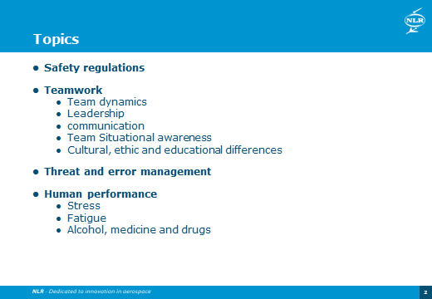
Total
time
35

