RRM training syllabus Chapter 5 HUMAN PERFORMANCE AND LIMITATIONS
Subject | Element | Objective | Trainer/trainee activity and key notes | Time | Tools / media
Human Performance and Limitations |  |  | - Introduce Human Performance and limitations.  - Ask what they know about Human Performance and Limitations.  Humans are very good at many things but not so good at some others. Some limitations can be mitigated by training others not. For example humans cannot hear above 20,000Hz, like for example dogs. We cannot see very well in the dark, compared to owls or cats. We have to take this into account when performing duties. Sometimes technology can help; night vision goggles. However, often these have drawbacks; heavy to wear, limited peripheral view, etc…  Our brain also has limitations; some of them will be discussed in this module.  - Ask if they experience limitations themselves and how they deal with that. | 2
 | Stress & Time pressure | - Knowledge on how stress affects human performance  - Notices stress factors  - Adequately manages stress | - Introduce the topic stress  Nowadays when we mention stress, we usually mean ‘too much stress’. Stress means ‘experiencing some sort of workload, having to do something’. This could be something very stressful such as a presentation before a huge audience or something involving (hopefully) very little stress such as making breakfast on a slow Sunday morning. So, the only time we do not experience stress is when we are asleep or dead.  - Explain the 4 categories of stress.  When we say we are stressed it usually means that we are very, or too busy at work. This is actually only one type of stressor. High or very low temperatures, fatigue and a fight with your partner can also raise stress levels.  When somebody is ‘burned out’ it means stress levels are so high it prevents somebody to keep functioning. Again, usually work pressure is focused on as cause. However, most people experiencing burn-out have at least one or two other stressors in their lives. When stressed it is very difficult to analyse a situation, even your own. You need somebody to help you identify the stressors in your life. | 10
 |  |  | - Explain what the different reactions to stress can be.  The cognitive effect of stress is very much like that of alcohol. Would you like to work with somebody on the ramp who is drunk?  - Explain that all stress factors have in common that they represent some kind of change on which an individual has to react. Whether stress factors cause a negative effect depends on the response, and the response is determined by an individual’s perception of the stress factor.  The way stress factors are perceived depends on:  - How a person feels;  - The stress factor itself;  - The evaluation of the stress factor;  - Personality;  - The ability and willingness of others to provide support.  - Show the impact stress in general has on performance.  - Ask which line represents the truth? | 10
 |  |  | - Ask for examples of personal stressors | 3 | Write catchwords on flip
 |  | - Knowledge on how time pressure affects human performance  - Notices when time pressure starts to affect human performance  - Adequately manages time pressure | - Explain that time pressure is one of the causes that lead to stress and stress has a negative influence on safety.  - Ask what can be possible causes:  - You have too much work,  - You are demanding too much of yourself,  - You are not assertive enough,  - You don’t have enough training or experience,  - Your department is undermanned,  - You are paying too much attention to side issues,  - You have too much ad-hoc activities,  - Your work environment is too turbulent,  - You are working under your level or have too little work,  - You don’t take brakes. | 5 | Write catchwords on flip and try to make the list complete (see column on the left)
 |  | - Knowledge on how stress affects human performance  - Notices stress factors  - Adequately manages stress | - Explain that coping is the manner in which a person deals with the environmental requirements of that moment with regard to behaviour, cognition and emotions.  - Explain the different ways how people cope with stress:  - Active  - Palliative reaction  - Avoiding  - Seek for social support  - Passive reaction pattern  - Expression of emotions  - Apply comforting and reassuring thoughts  (see PPT for explanation)  - Ask: which one of these reactions is the best?  That depends. In the short term Avoidance could be best, in the long term dealing with it Actively (problem solving).  Comforting thoughts work very well; it is only temporarily, it is only one nasty colleague, etc…  Also social support is very important; because you are stressed it is difficult to see solutions or to put things into perspective. Use your partner, friends, and colleagues!  - Ask if they recognize some of those with themselves or others? | 10
 |  |  | - Explain how you can actively prevent stress  - Planning and preparation  - Setting boundaries  - Solve personal problems (!)  - Recognise and reduce self-induced stress  - Use colleagues spare capacity  Otherwise: Sorry, can’t do it! There is always a way out/solution (comforting thoughts!) | 5
 | Fatigue | - Knowledge on how fatigue affects human performance  - Notices when fatigue starts to affect human performance  Adequately manages signs of fatigue | - Introduce the topic Fatigue  - Explain that fatigue can be both physical and mental.  - Physical fatigue is the inability to continue functioning at the level of one's normal abilities; a person with physical fatigue cannot lift as heavy a box or walk as far as he could if not fatigued.  - Mental fatigue, on the other hand, rather manifests in sleepiness or slowness. A person with mental fatigue may fall asleep, may react very slowly, or may be inattentive  Fatigue has very similar effects to stress and thus to alcohol. It all inhibits our ability to think.  - Ask: what could be the safety effect?  - Show: video of sleepy driver; it can all go very wrong within seconds. No drivers were (seriously) hurt in the making of this video.  - http://www.youtube.com/watch?v=mIcG2lnDmqk | 3 | 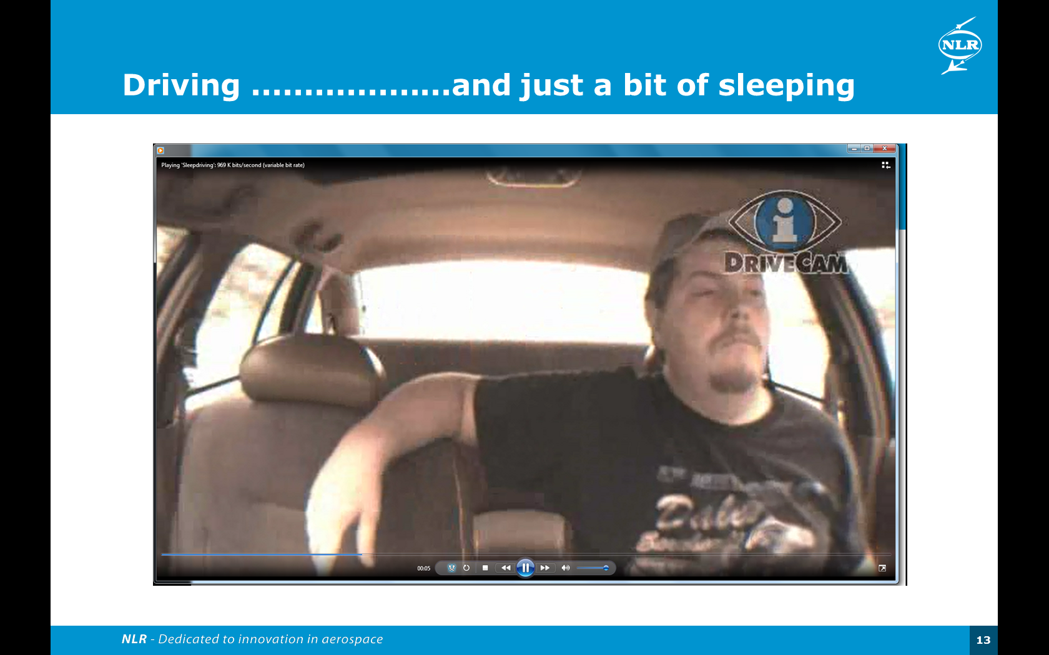
 |  |  | - Explain that studies on fatigue consistently show that fatigue is an on-going problem in aviation safety. Fatigue can result in human error, slowed responses, missed opportunities, and incorrect responses to emergency situations.  - Explain the causes of fatigue: lack of sleep, long hours of physical or mental work, working at night, stress, health problems, sleep disorders, or a combination of these issues. | 2
 |  |  | - Ask how you can recognize signs of fatigue at yourself and other?  Yourself:  • fall asleep at the desk,  • feel restless and irritable with people,  • have to check my work repeatedly,  • have difficulty focusing on tasks,  • feel like I really just don’t care.  All of us may be fatigued if we have difficulty:  • understanding a complex situation,  • avoiding distractions,  • keeping track of the current situation,  • updating strategies  • thinking about several things at once  • being innovative  • assessing risk and/or anticipating consequences  • maintaining interest in outcomes  • controlling mood and avoiding inappropriate behaviour | 10 | Write chatchwords on flip-over  and try to make the list complete like in the left column.
 |  |  | - Explain that to manage shift work and reduce the of fatigue, responsibilities lie with both the managers and employee  http://www.mirsa.com.au/docs/Fatigue_Management.pdf | 10
 | Medicines | - Knowledge on how medicines affect human performance  - Reports medicines use | - Explain the effects of Alcohol, medicine and drugs.  - Emphasize the effect the use of new medicine can have on performance. You don’t know you reaction to the medicine as of yet so be prudent and report! | 5
Total time
75

