Comment |  |  |  | Comment summary | Suggested resolution | Comment is an observation  (suggestion)* | Comment is substantive (objection)** | EASA  comment disposition | EASA response
NR | Author | Section, table, figure | Page
1
2
3
4
5
6
7
8
9
10
11
12
13
14
15
16
17
18
19
20
21
22
23
24

* Please complete this column using the word “yes” or “no”
** Please complete this column using the word “yes” or “no”
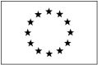
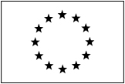
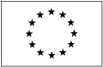
An agency of the European Union
Page 62 of 62
© European Aviation Safety Agency. All rights reserved. ISO9001 Certified.
Proprietary document. Copies are not controlled. Confirm revision status through the EASA-Internet/Intranet.

