Comment |  |  |  | Comment summary | Suggested resolution | From the commenter point of view a modification of the published text is*:  -Not requested;  -Recommended;  -Requested | EASA  comment disposition | EASA response
NR | Name of the organisation commenting | Section, table, figure | Page
1 |  |  |  |  |  | Choose an item. | Choose an item.
2 |  |  |  |  |  | Choose an item. | Choose an item.
3 |  |  |  |  |  | Choose an item. | Choose an item.
4 |  |  |  |  |  | Choose an item. | Choose an item.
5 |  |  |  |  |  | Choose an item. | Choose an item.
6 |  |  |  |  |  | Choose an item. | Choose an item.
7 |  |  |  |  |  | Choose an item. | Choose an item.
8 |  |  |  |  |  | Choose an item. | Choose an item.
9 |  |  |  |  |  | Choose an item. | Choose an item.

* Please complete this column using the drop-down list

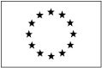
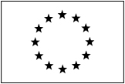
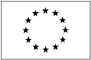
An agency of the European Union
Page 62 of 62
© European Aviation Safety Agency. All rights reserved. ISO9001 Certified.
Proprietary document. Copies are not controlled. Confirm revision status through the EASA-Internet/Intranet.

