The Menace of Unruly Passengers – Fly Right this Summer
The safety and security of both passengers and crew is our top priority in aviation. However, the rising number and severity of unruly passenger incidents pose a major risk to the safety and well-being of everyone onboard, as well as to staff members working on the ground. This article aims to shed light on the dangers associated with unruly behaviour and proposes solutions for national authorities, airlines, and airports to tackle this pressing issue. It provides the foundation of information to encourage everyone to "Fly Right this Summer”.
The threat unruly passengers pose to flight safety
Unruly passenger incidents encompass a range of disruptive behaviours, including verbal and physical altercations, non-compliance with crew instructions, and intoxication. Such incidents can jeopardize the safety of the flight in several ways:
- Crew Distraction: Disruptive passengers divert the attention of flight crew from their primary responsibilities, which involve ensuring the safe operation of the aircraft, communicating with air traffic control, and managing in-flight emergencies. This distraction can hinder their ability to respond effectively to critical situations.
- Physical Altercations: Acts of violence or aggression among passengers can escalate quickly, posing risks to the safety of both individuals involved and other innocent passengers. Altercations can compromise the overall cabin atmosphere, potentially leading to panic or unrest among other passengers.
- Interference with Equipment: Unruly passengers may tamper with safety equipment, including emergency exits, smoke detectors, or life-saving equipment, endangering the safety systems designed to protect passengers in the event of an emergency.
- Flight Diversion: In extreme cases, when unruly behaviour poses an immediate threat to the safety of the aircraft and its occupants, pilots may be forced to divert the flight to the nearest suitable airport. This diversion incurs significant costs for airlines and inconvenience for passengers, potentially causing delays in subsequent flights.
The risks to passengers and staff
The risks associated with unruly passenger behaviour extend beyond flight safety. They also pose threats to passengers and staff both in the air and on the ground:
- Physical harm: Unruly passengers can cause physical harm to other passengers and cabin crew members. Acts of violence may result in injuries that range from minor to severe, jeopardizing the well-being and health of individuals onboard.
- Emotional distress: The presence of unruly passengers creates a stressful and unsettling environment for everyone on the aircraft. Both staff and passengers may feel intimidated, fearful, or anxious, leading to emotional distress. It vital that all aviation organisations have processes to support their staff following an unruly passenger event.
- Ground incidents: Unruly passengers are also a problem on the ground. Data shows that disruptive events can happen anywhere in the airport. From check-in and security to the departure lounge and gate area these types of incidents can disrupt airport operations, leading to delays, inconvenience, and compromised security protocols. It is vital that all airport stakeholders, including local law enforcement, work together to identify situations and take early action to de-escalate any potential disruptive behaviour.
Increasing numbers and an increase in severity
Data from EASA shows that the number of unruly passenger events has increased over recent years, particularly since the COVID-19 pandemic. The rate of events (number of events per 1,000 movements) increased during the pandemic but has since reduced. What is most worrying is that the severity of the incidents appears to have increased considerably. Having discussed this with a number police services in different countries, this matches what they see happening in the general population. Flying, combined with alcohol and prescription/ illegal drugs can be a dangerous mix that creates risks that we must manage collectively as an industry.
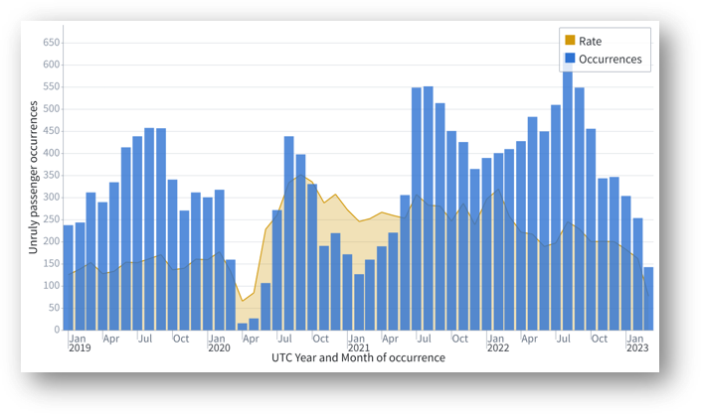
Solutions and Actions
Addressing the menace of unruly passengers requires a collaborative effort between national authorities, airlines, and airports. Here are some proposed solutions and actions to mitigate the risks:
- Stricter legislation: On of the most important things is for individual countries to enact or enhance legislation that explicitly criminalises unruly behaviour on aircraft. This helps to serve as a deterrent and provide a legal framework to punish offenders appropriately. In Europe, it is important that countries ratify and enter ICAO Montreal Protocol 14 (MP14) into force. Without MP14 in place it is very difficult for police to take action against unruly passengers on aircraft either registered outside their country or operated by an airline in their country.
- Crew/ staff training: It is important that ground staff and crew members are trained and prepared to handle unruly situations. Airlines, airports and ground handling companies should invest in comprehensive training programs for staff members, equipping them with the necessary skills to defuse conflicts, handle unruly passengers, and maintain control of the cabin environment. Training should focus on conflict resolution, communication, and recognizing early signs of potential disruptive behaviour. It is also important that aircraft commanders and managers on the ground are aware of their role as decision makers in disruptive situations.
- Collaborative reporting systems and effective communication: A risk can only be managed when staff are encouraged to report it. Occurrences involving unruly passengers should be reported using your organisation’s Safety Management System. Additionally, occurrences should be forwarded to your National Aviation Authority as a Mandatory Occurrence Report (MOR). Use the information from reports to identify airports and situations where the risk is greatest and work collaboratively with local staff on mitigations. It is also important to communicate continually at an operational level between all stakeholders at the airport to help manage situations in real time.
- Enhanced security measures: Airports should strengthen security protocols, including stricter checks at departure gates and screening for signs of intoxication or aggression. The presence of visible security personnel can act as a deterrent and reassure passengers of their safety. It is also important to have effective community policing at airports.
- Passenger education and customer experience: Airlines and airports can play a crucial role both in raising awareness among passengers and to ensure that the customer experience does not add to the stress of passengers. Make passengers aware of how they can be ready to fly so that their journey is as stress-free as possible and also to make them aware of the consequences of unruly behaviour. It is also important that management and staff monitor the passenger journey to identify and resolve any hot spots that might lead to an increase in unruly events.
What you can do?
Unruly passengers pose significant risks to the safety and well-being of passengers, crew members, and individuals on the ground. These are the key actions that you can do within your organisation to help manage the risk of unruly passengers.
- Unite for Success: Collaborate, Communicate, and Conquer - Join the aviation industry in setting clear expectations, efficient communication, and effective information sharing. Identify and manage unruly passengers together, avoiding passing the problem to the cabin.
- Empower Your Staff: Equip your staff with the skills and training to handle difficult situations. Detect and mitigate issues early to minimize impact on passengers and crew. Foster collaboration with local police and airport security when necessary.
- Stand by Your Staff: Support your frontline heroes with comprehensive training, including exceptional communication skills. Provide clear expectations, robust procedures, and back their operational decisions. Prioritize their well-being post-event.
- Help Passengers to Fly Right: Prepare your passengers for a smooth journey by sharing practical and relevant information before their flight. Rapidly communicate any delays and explicitly state zero tolerance for misbehavior, which can lead to early termination or prosecution.
- Walk in Their Shoes: Continuously evaluate the passenger journey to ensure consistent messaging, exemplary staff behavior, and reduce stressors that may trigger disruptive behavior. Let empathy guide your approach to create a harmonious travel experience.
Get involved in EASA’s Unruly Passenger Campaign
Thankfully you are not on your own in working on this subject. EASA has teamed up with organisations from across the aviation community to develop a safety campaign to help. The campaign will start on 19 June and then launch to the general public on 23 June.
In addition to this leadership think paper the campaign provides the following resources that are copyright free for you to add your logos and use as you want:
- Free webinars that you can join on 19 June to learn more about the challenge of unruly passengers and on 21 June on how to help passengers and support your staff.
- Campaign brief with the main messages that you can use in your own communications to staff and passengers.
- Draft article that you can use in your own safety magazine and supporting staff promotional material.
- Draft material for passengers that you can use on your website and promotional material for passengers, including social media images and other advertising material for use on TV screens and in toilets etc.

