The Menace of Unruly Passengers – Fly Right this Summer
Here at <insert airline name> the safety and security of both passengers and crew is our top priority. With the introduction of mask requirements during COVID we saw a considerable increase in the number of unruly passenger events. This was something impacting the whole industry not just us. More recently, the whole industry has seen continued challenges with unruly passengers. We have joined forces with other airlines, airports and handling companies to be part of EASA’s campaign to encourage passengers to "Fly Right this Summer”.
This article provides some information on the key challenges, what we are communicating to our passengers and what you can do as individual staff members.
The threat unruly passengers pose to the safety of our flights
First it’s useful to be clear what we are talking about. Unruly passenger incidents encompass a range of disruptive behaviours, including verbal and physical altercations, non-compliance with crew instructions, and intoxication. There are many ways such incidents can jeopardize the safety of our flights:
- Crew Distraction: Disruptive passengers divert the flight crew’s attention from their main task of flying the aircraft, communicating with air traffic control, and managing in-flight emergencies. This distraction can hinder their ability to respond effectively to critical situations.
- Physical Altercations: Acts of violence or aggression among passengers can escalate quickly, posing risks to the safety of both individuals involved, other passengers and particularly crew members. Altercations also compromise atmosphere of the cabin – we want all our passengers to enjoy their flights with us.
- Interference with Equipment: Unruly passengers may tamper with safety equipment, including emergency exits, smoke detectors, or life-saving equipment, endangering the safety systems designed to protect passengers and crew in the event of an emergency.
- Flight Diversion: In extreme cases, when unruly behaviour poses an immediate threat to the safety of the aircraft and its occupants, the crew are forced to divert the flight to the nearest suitable airport. This diversion incurs significant costs and causes a huge knock-on effect to the operation, definitely something we want to avoid.
The risks to passengers and staff
The risks associated with unruly passenger behaviour extend beyond flight safety. They also pose threats to your safety when you come to work, as well as the risk to passengers.
- Physical harm: Unruly passengers put people at risk of physical harm – we want you to be able to come to work and feel safe at all times.
- Emotional distress: It should also be recognised that unruly passengers create a stressful and unsettling environment for everyone. Being involved in such a situation naturally impacts the wellbeing of staff involved. We are here to support you so please reach out to our Wellbeing support team at any time.
- Ground incidents: It is important to know that unruly passengers are also a problem on the ground. From check-in and security to the departure lounge and gate area. Our ground teams are working closely with all of our airports and particularly local law enforcement to help identify situations and take early action to de-escalate any potential disruptive behaviour.
Increasing numbers and an increase in severity
Data from EASA shows that the number of unruly passenger events has increased over recent years, particularly since the COVID-19 pandemic. The rate of events (number of events per 1,000 movements) increased during the pandemic but has since reduced. What is most worrying is that the severity of the incidents appears to have increased considerably. Having discussed this with a number of police services in different countries, this matches what they see happening in the general population. Flying, combined with alcohol and prescription/ illegal drugs can be a dangerous mix that creates risks that we must manage collectively as an industry.
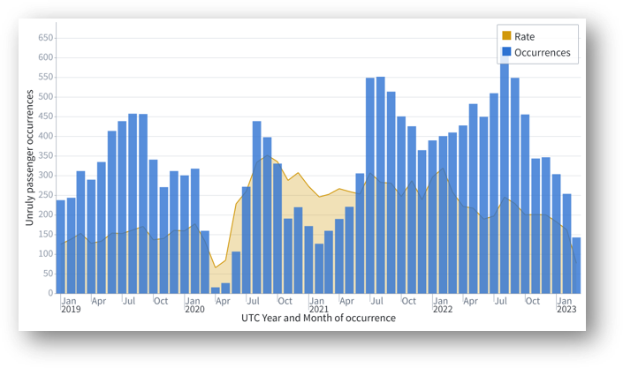
Communication and promotion to our passengers
One of the biggest things we are doing is to use the material from EASA’s “Fly Right this Summer” campaign to help educate our passengers. We must strike a fine balance in the tone we take with our passengers. The vast majority of them behave perfectly so we don’t want them all to think we are accusing them of being terrible people before they even set foot on the aircraft.
We have 3 key messages that we will be communicating to our passengers throughout the summer. The information will be provided via our social media, on our website and we will also be using screens around the airports in our network wherever we can to influence the passengers’ behaviour. Under each message there are additional tips and useful information to help passenger to be ready and “Fly Right”.
- Ready for Flight: Follow our tips for a smooth journey.
- Be Polite: Be nice to staff and other passengers.
- Don't Fight: Bad behaviour will not be tolerated.
The legal situation:
At a global level, the International Civil Aviation Organisation (ICAO) and a UN organisation that governs the world of aviation. When it comes to unruly passengers, ICAO developed something called ICAO Montreal Protocol 14 (MP14) that provides a framework for countries to enact or enhance legislation that explicitly criminalises unruly behaviour on aircraft.
This helps to serve as a deterrent and provide a legal framework to punish offenders appropriately. In Europe, EASA is working with the different National Aviation Authorities (NAAs) to help them ratify MP14. Without MP14 in place it is very difficult for police to take action against unruly passengers on aircraft either registered outside their country or operated by an airline in their country so its pretty much a no brainer.
From our side, the situation regarding MP14 in different countries shouldn’t impact the decisions we take in the cabin. It might make the follow up more difficult, but the safety team will support you with any follow up and you will receive full pay for any time outside your normal duty period you spend dealing with unruly passenger follow up.
What you can do?
Here are the key actions that you can take to help manage the risk of unruly passengers:
- Unite for success: Collaborate, communicate, and conquer. Collaborate with each other in your crews/ teams. Also work closely with staff in the other organisation we work with around the airport. Identify and manage unruly passengers together and support each other in deescalating difficult situations.
- Empowering you: As crew/ staff members, we appreciate that you must take difficult operational decisions based on the situation you are facing. Hopefully you will have received all the training you need to handle difficult situations in your specific job role. If you are unsure of your role regarding unruly passengers or require support with training, please contact your team’s training lead – they are there to help you.
- Standing by you: You will have the full support of the company for any decision you make concerning unruly passengers.
- Encouraging reporting: Please report any situations involved unruly passengers. When you are part of a crew or team, discuss together who will make the report. When you report, please provide as much information as possible. This information helps use work out how to best mitigate the risks in different situations or locations. We will also communicate any follow up information as quickly as possible, so you get feedback on your reports.
- Help our passengers to Fly Right: Support our passengers whenever you can. For many people it will be the first time they have flown since 2019 so they may be a lot more nervous to fly. Communicate with passengers whenever you can and go the extra mile to make their journey memorable.
- Walk in Their Shoes: Finally, walk in our passengers’ shoes by thinking about things from their point of view. If you spot a passenger pinch point, please tell someone so any challenging situations can be solved.

