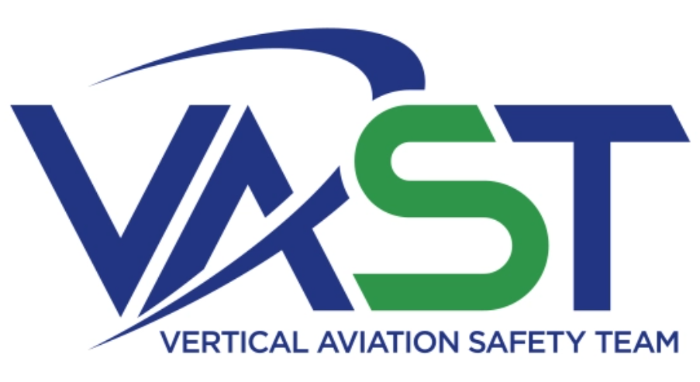 | 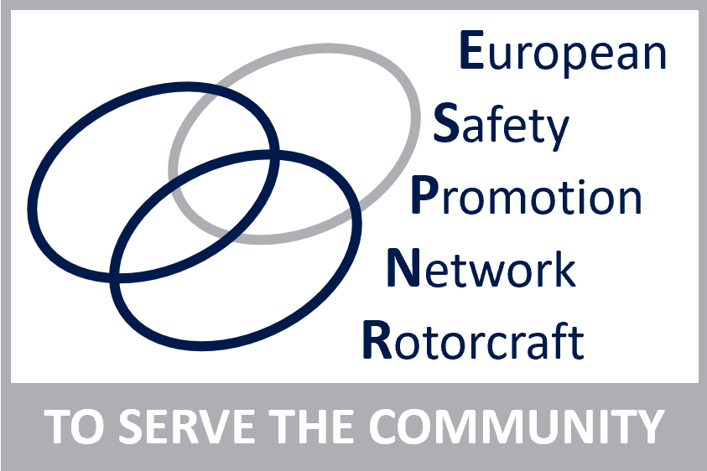

Vertical Aviation Safety Team – VAST – Safety Above All

International Rotorcraft Community Launches Collaborative Safety Program
June 1st, 2021

International rotorcraft safety organizations, regional safety teams, and other global safety stakeholders are pleased to announce the establishment of the Vertical Aviation Safety Team (VAST). In cooperation and collaboration with the worldwide vertical flight community, VAST aims to achieve a vision of zero fatal accidents, providing “Safety Above All.” In pursuit of that vision, VAST will use a data-informed, consensus-based approach to better harmonize, coordinate, and implement global safety information, resources, and programs, and to support regional safety efforts.

The international vertical take-off and landing (VTOL) industry includes many groups working to reduce accidents, including regional safety teams, industry safety organizations, businesses and associations with safety components to their missions, as well as the individual operators, pilots, maintenance professionals, and others who work daily to mitigate the inherent risks of aviation. The International Helicopter Safety Team and, later, the International Helicopter Safety Foundation previously represented these global safety stakeholders.

Regional safety teams will continue to lead safety initiatives in their respective areas. The role of VAST is to engage with those teams and other safety stakeholders to integrate, harmonize, distribute, and promote the resulting safety data, programs, and recommendations worldwide, reducing duplicative efforts and enabling more efficient use of resources. Several VAST working groups will oversee the organization’s efforts in areas such as technology, regulations, and safety promotion.

VAST represents the combined voices of the worldwide rotorcraft community. Its operations are overseen by two advisers: James Viola, President and CEO of Helicopter Association International, and Miguel Marin, Chief Operational Safety, at the International Civil Aviation Organization (ICAO). Their advisory role will help VAST meet its objectives building on industry best practices and the latest international standard developments.

“VAST like other Safety teams are proven initiatives to reduce accidents on a global level,” says Marin. “Bringing the international industry and regulator community together will create a consistent program striving to make the global rotorcraft community as safe as possible.”

“Statistics show that accidents in our industry share the same causes, regardless of border or language,” says Viola. “VAST will bring together safety advocates from around the world to collaborate on finding the most effective safety initiatives and then sharing them with the VTOL community.”

“VAST will be a forum where regional teams, industry and authorities will work together on Vertical Flight safety. This revamped initiative builds on the previous International Helicopter Safety Foundation (IHSF) and is fully compatible with the priorities set out in the EASA Rotorcraft Safety Roadmap that aims to reduce accidents by 50% over the period 2019-2029 and to expand its scope to Vertical Aviation. Our priorities are on technologies with safety benefits, operational aspects, training using new technologies and safety promotion. We are very pleased to work together with other regional teams and organizations in the VAST and contribute to driving this international initiative. In safety, cooperation is key and VAST is the future of Vertical Aviation cooperation!” says Michel Masson, EASA Senior Safety Promotion Officer, ESPN-R Coordinator.

Industry stakeholders, the public, and anyone who wishes to learn more about improving VTOL safety should visit the VAST website, www.vast.aero. In addition to providing more information about VAST, this site will be a key access point for information on safety programs, policies, tools, and promotional products for the global industry.

